--1
¥:1(*-*
_ (
:_
EXCELLENCE
IN POLICING INI rf ATIV'.E"

Use of, FOrcetPol.i c,f
,",; vi;• · ,
' "-

• • ·
,, " ,;.:
-, ,
.,,.
'.r1: '
_.:;_
, ur

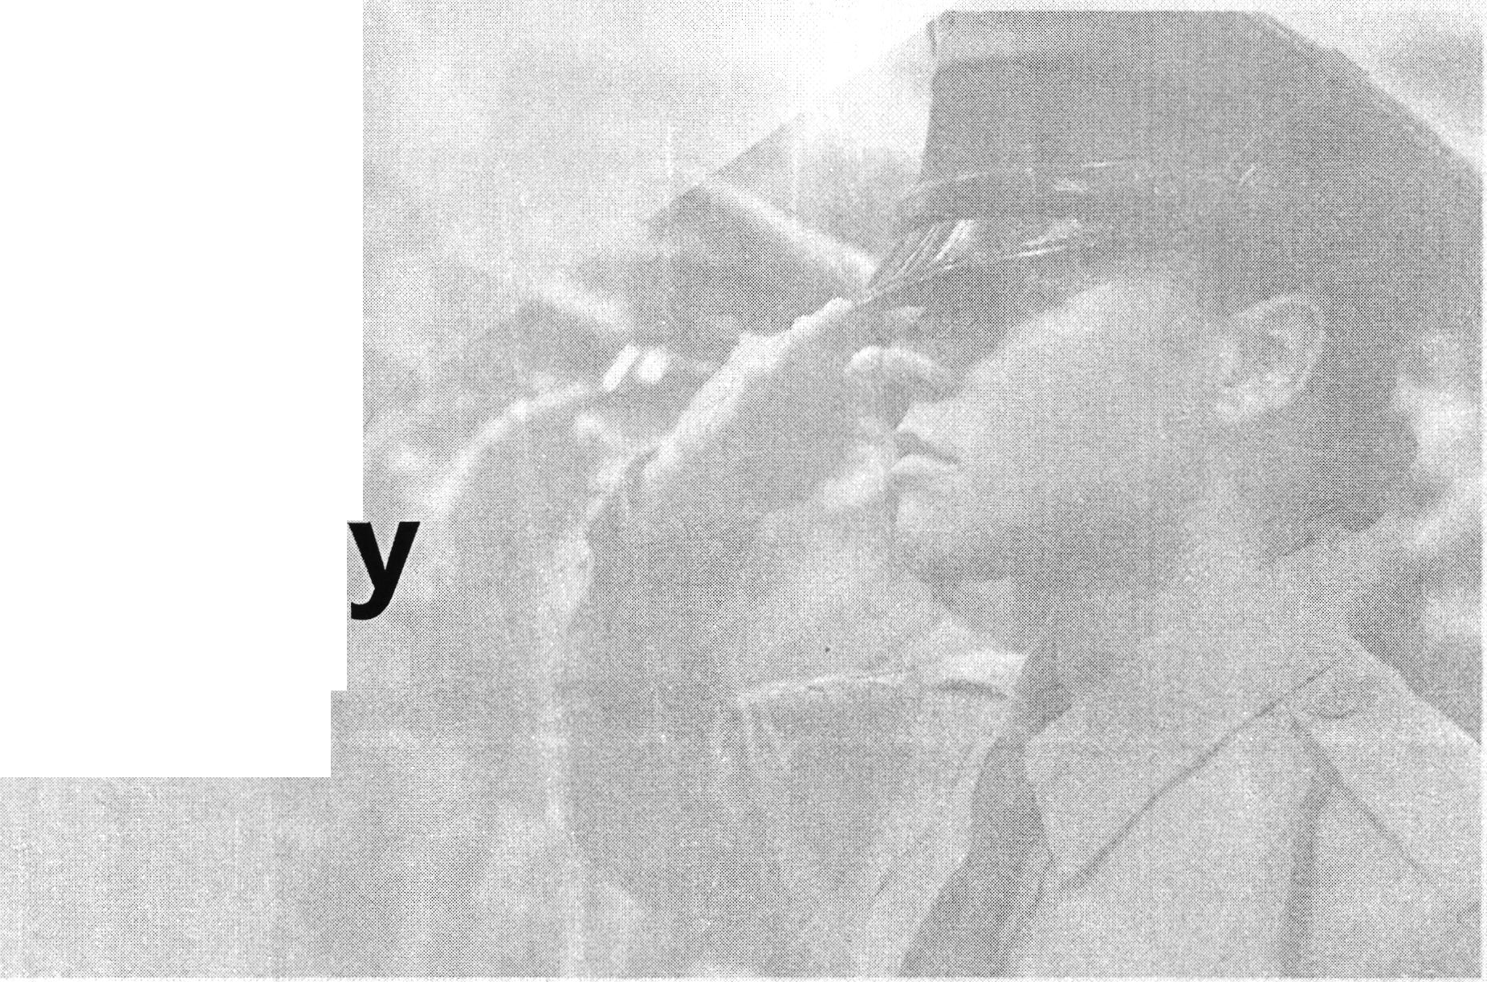Rev tstonsi; P-roc:es:s

(·

21 County 21st Century Community Policing Project

21121
- Established in 2018
- Goal is to strengthen relationships between law enforcement officers and the communities they serve
- Attendees include a mix of law enforcement officers, community leaders, faith leaders and a host of other NJ stakeholders

r:. :")EX CELLEN CE
  - IN POLlCING JNITlAT!VE

P, ROFESSIONALISM
Improving law enforcement training
Overhauling the state's Police Training Commission
Promoting officer resiliency
Identifying early warning signs for at-risk officers
ACCOUNTABILITY
- Ensuring independent investigations of officer­ involved shootings
- Creating a more robust police disciplinary process
Developing a proposal for police licensure
II Setting minimum standards for Civilian Review Boards
EXCE'LLE N CE
IN POLfCING INITIATIVE
TRANSPARENCY
- Ensuring the public release of police use-of­ force footage
- Creating systems for timely disclosure of impeachment material
- Collecting and publishing statewide data on police use-of-force

Recent Updates to EIP Reforms

- Expanding "Crisis Intervention Team" Training
- Endorsing Statewide Licensing for Police Officers
- Launching Statewide Use of Force Portal
- Updating Use-of-Force Policy

- Cr eat ing·Divisio n on Civil Rights Incident Response Team

··:c
- \J EXCELLEN CE
' IN POLICING IN ITlA 'flVE

Existing Use of F9rce Policy

  - Issued 1985

Revised June 2000. The existing Use of Force policy can be found at the Excellence in Policing section, Use of Force Comment Portal tab on the Attorney General's Website.
'

Provides guidance to law enforcement officers about when and how

force can to be used to gain compliance with a lawful objective.
r

Law enforcement officers are per m it t edM t o use only thatforce which+i s

obJ.eet·1veI

y reasonabl
e and

necessary.
@· . E. ·XrNC..!_'_E2u Lg NLGErNNmCATrvE

Updating the Us o, f Force Policy

- Lead by Office of Integrity & Accountability (OPIA)
- Drawing on input from stakeholders and best practices

.Ii" ,, ,f'
from around the country and the world · ·

- Finalize New Use of Force Policy no later than the end of
2020

@EXCELLENCE
.. ' IN POUCJNG INITIATIVE

Community Engagement

uThe Use of Force Policy affects everyone/ and so everyone should have the opportunity to weigh in on its revisions// said Attorney General Grewal. uwe want to hear from a broad cros.s-section of our state: police officers, civil rights advocates, religious leaders, victims' rights organizations, and community members. We especially want to hear from those that have had negative experiences with law enforcement officers because we are committed to getting this right. By engaging residents across New Jerse½ we will ensure that the updated policy reflects New Jersey/s values.//

EXCELLENCE
.. ,... -. IN POLICING lNTTlATIVE

Public Comment Portal
•
. ,._.O.'
- ,"

Accepting submissions until August 1, 2020

:

. EXC ELL ENCE
C,LlCING tN!TIAtlVE

Areas for Revision

- Specific tactics designed to subdue a subject
- Engaging subjects with serious mental illness or substance abuse issues
- Exhausting all other reasonable means and pursuing de-escalation before resorting to deadly force
- Applying force proportionate to the subject's alleged conduct
- Less-than-lethal uses of force
- Duty to intervene when another officer engages in excessive use of force
- Firing a weapon at a moving vehicle
- High-speed car pursuits
- Reporting and training requirements
- Any other proposals that reduce the risk of injury and death to civilians while
maintaining the safety of police officers. _
- ALL INPUT IS WELCOME ON ANY ASPECTS OF THE USE OF FORCE P O. - -- EXCELLENCE
\g IN POLICING INITIATJVE

