Jkkk
HIDDEN IN PLAIN SIGHT
A free substance abuse prevention awareness program

Wednesday, April 10, 2019
Metuchen High School, 400 Grove Avenue, Metuchen, NJ
6:30 PM – Light Dinner and Teen Development Networking
7:30-8:30 PM - Presentation
The Metuchen Public Schools, Metuchen High School Project Graduation and the Metuchen Municipal Alliance invite you to a parent workshop that will increase your awareness with an interactive tour to see what could be hidden in a child’s bedroom.

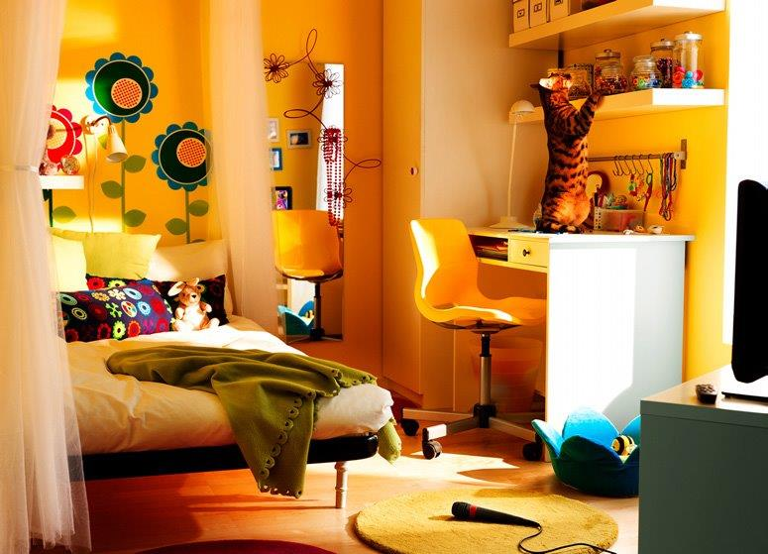

Hidden in Plain Sight is a hands-on learning opportunity presented by Special Agent Timothy P McMahon, Public Information Office, Drug Enforcement Administration, NJ Division, Newark. Tim brings the audience through an actual set up of a teen bedroom, highlighting signs and symptoms of alcohol/drug abuse while teaching skills for proactive parenting and addressing possible problems.

For ALL parents, caregivers, adults over 21, community members, educators and adults working with youth. No one under 21 will be permitted to attend. During dinner at 6:30, a network of representatives from local agencies will share their expertise about child/teen development, anxiety and other issues.

For more information contact Judi Cheung 732-321-8744, x-5028 or jcheung@metboe.k12.nj.us

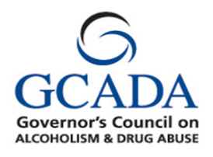
Sponsored by the
Metuchen Municipal Alliance
through funding received by the Middlesex County Office of Human Services
and the NJ Governor’s Council on Alcoholism and Drug Abuse.
